







+91 9313035076, +91 9537651265
info@bkexportsinternational.com www.bkexportsinternational.com
90, Jasodanagar Cross Road, Nr. Canal, Opp. Baroda Express Highway, Amraiwadi, Ahmedabad, Gujarat, India - 380026

TOTAL |  |  |  | 599369.00 |  |  | 565557.00 |  |  |  |  |  | 0.00
TOTAL INVOICE VALUE (IN FIGURE) |  |  |  |  |  |  |  |  |  |  |  |  | 565557.00
TOTAL INVOICE VALUE (IN WORDS) : FIVE LAKH SIXTY FIVE THOUSAND FIVE HUNDRED FIFTY SEVEN RUPEES
 | BANK NAME : BANK OF BARODA
 | BRANCH NAME : Maninagar East
 | BANK A/C NUMBER :14970200000658 |  |  |  |  |  |  |  | 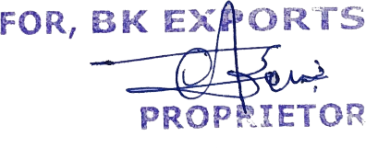
 | BANK IFSC CODE : BARB0MANEAS
 | BANK ACCOUNT TYPE : CURRENT
DESIGNATION : PROPRIETOR
STATUS: REGISTERED
ELECTRONIC REFERENCE NUMBER

